**Lab 1 Equipment, Documentation and Lab Familiarization**

**Keegan** **Smith**

**Bench** #19

**Electronics** 1 Lab

**EECE.3110**

**Date submitte**d 02/xx/2022

**Due date** 02/13/2022

1. **SUMMARY**

N/A

1. **EQUIPMENT**

**Table 1. Equipment**

|  |  |  |
| --- | --- | --- |
| **Equipment Type** | **Details** | |
| * Oscilloscope | *Make:* | InfiniiVision |
| *Model:* | DSO-X2004A |
| *Serial Number:* | MY52161432 |
| * Digital Multimeter, Bench Top | *Make:* | Keithley |
| *Model:* | 2110 5½ |
| *Serial Number:* | 8004026 |
| * Digital Multimeter, Handheld | *Make:* | Tenma |
| *Model:* | 72-9385 |
| *Serial Number:* | H200487467 |
| * DC Power Supply | *Make:* | GWInstek |
| *Model:* | GPD-3303D |
| *Serial Number:* | EM840514 |
| * Analog Discovery | *Make:* | Digilent |
| *Model:* | Analog Discover 2 |
| *Serial Number:* | 210321B0DF82 |
| * Breadboard * Bench “Shoebox” with connector cables, adapters, clips etc. | N/A | |

1. **INTRODUCTION**

The Analog Discover 2 is a power tool make by Digilent that functions as nearly every tool one would need in the lab all in one. This device can work as a power supply, waveform generator, voltmeter, data logger and Oscilloscope. This is a very important tool to be familiar with, not just to be able to work on labs from home, but it is useful for field applications too so one does not have to carry multiple expensive devices with them.

The bread board is an important tool for temporarily running circuits. Being able to stick wires and components in without constantly solder and de-solder is very useful and a time saver.

A handheld multimeter is an engineer’s best friend and one that students should be very familiar and comfortable with using. Being able to accurately measure voltage, current, resistance, capacitance, continuity, diode polarity and much more in a palm of one’s hand is powerful.

A benchtop digital multimeter is much like its handheld counterpart however, due to not having a size constraint as the handheld meters do, the benchtop meters can produce more accurate readings.

Function generators are used to produce a signal to test circuits. These generators can supply sine, square, triangular, pulse, and DC signals.

The oscilloscope is used to measure signals. However, it does much more. An oscilloscope as the ability to measure and compare multiple signals at once as well as perform mathematical functions based on the signals to calculate peak voltage, peak to peak voltage, slew time, time shifts, and more.

1. **CIRCUIT DESCRIPTION**

Figure a.

This is the circuit diagram used to construct the PowerBRICK circuit. The circuit allows for the ADK to supply 12v.

Figure b.

Network Analyzer Test Circuit

Figure c.

Sensing circuit

This is the sensing circuit that I constructed. I decided to use a 1KΩ resistor to make calculations and measurements easier. This circuit works as a voltage divider, if I chose a smaller value for my sensing resistor the voltage would be significantly smaller that with the 1KΩ. For example, I originally used a 10Ω resistor, which only drew about 76mV, too small for the handheld multimeter to make an accurate reading.

1. **MEASUREMENTS**

**Table 1.** Handheld DMM

|  |  |  |
| --- | --- | --- |
| Measurement type | Expected | Measured |
| Voltage readings | 5V | 4.98V |
| Current readings | .5A | .49A |
| Resistance readings | 1.2KΩ | 1.17KΩ |
| Capacitor readings | 22.3nF | 21.4nF |

**Table 2.** Benchtop DMM

|  |  |  |  |
| --- | --- | --- | --- |
| Reading | Expected | Measured | Percent Error (%) |
| 15A fuse | >5Ω | 5.3Ω | N/A |
| 3A fuse | >10Ω | 5.457Ω | N/A |
| Capacitor readings | 470µF | 517.2µF | 10.0426 |
| 1000µF | 1106µF | 10.6 |
| 10µF | 10.62µF | 6.2 |
| 1µF | 0.955µF | 4.5 |

**Table 3.** Oscilloscope Automatic Measurements

|  |  |
| --- | --- |
| Frequency | 2KHz |
| Period | 500ms |
| Rise time | <60ns |
| Fall time | <60ns |
| (+) Pulse width | 200ns |
| (-) Pulse width | 300ns |
| (+) Duty cycle | 40% |
| (-) Duty cycle | 60% |
| Vpp | 4.7V |
| Vp | N/A |
| Max peak Voltage | 2.11V |
| Min peak Voltage | -2.55V |
| Mean | N/A |
| RMS | 2.28V |
| Cycle RMS | 2.28V |

The measurements in the table above are taken from the automated measurement feature in the benchtop oscilloscope. The input signal was 2KHz with a peak-peak voltage of 4.0V and was outputted by the function generator.

**Figure 1.** Screen grab of the “snapshot all” function

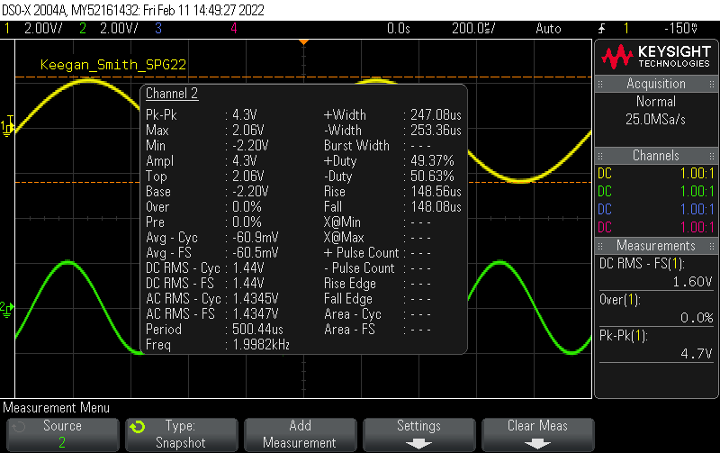

**Table 4.** Manual Cursor Measurements with the Oscilloscope Channel 1

|  |  |
| --- | --- |
| Period | 998.0µs |
| Vpp | 4.66325V |
| Vp | 2.20V |
| Time between zero crossings | 998.00µs |
| High pulse width | 498.0µs |

This input of this is channel 1 from the function generator whose output was 2KHz with an amplitude of 4.0 volts peak-peak.

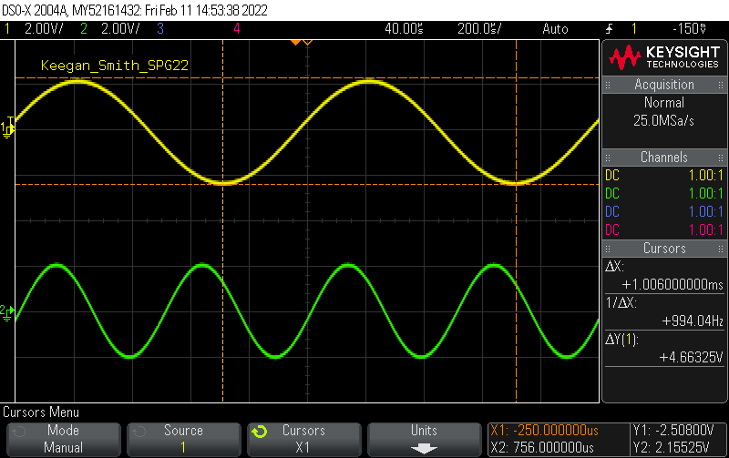**Figure 2.** Time between zero crossings (delta X) and Voltage peak-peak (delta Y)

**Figure 3.** Measuring the high pulse widthGraphical user interface

Description automatically generated

**Table 5.** Manual Cursor Measurements with the Oscilloscope Channel 2

|  |  |
| --- | --- |
| Period | 500µs |
| Vpp | 4.2V |
| Vp | 2.04V |
| Time Between Zero Crossings | 499.255µs |
| High Pulse Width | 250.0µs |

This input of this is channel 2 from the function generator whose output was 1KHz with an amplitude of 4.5 volts peak-peak.

**Table 6.** Sensing resistor Circuit voltage values

|  |  |  |  |
| --- | --- | --- | --- |
| Method | 8V Power supply | 5V Analog Discovery | 12V Analog Discovery with PowerBRICK |
| Calculation | 4V | 2.5V | 6V |
| Oscilloscope | 3.9V | 2.4V | 5.99V |
| Handheld DMM | 3.86V | 2.46V | 6.08V |
| Analog Discovery DMM | 3.88V | 2.507V | 6.095V |
| Analog discovery Data logger | 3.87V | 2.50V | 6.0935V |

The sensing circuit (Figure c.) consisted of two 1KΩ resistors in series, the second of them being the sensing resistor. Calculations are done with voltage division:

$Vx=Vin\frac{R2}{R1+R2}$ (1)

**Figure 4.** 8V sense voltage reading on oscilloscope with max voltage reading

**Table 7.** Analog Discovery Meter vs. Analog Discovery Data Logger vs. Handheld DMM

|  |  |  |
| --- | --- | --- |
| Device | Channel 1: 1KHz 4.5Vpp | Channel 2: 2KHz 4.0Vpp |
| Handheld DMM | 770mV | 233mV |
| Analog Discovery DMM (RMS) | 761mV | 629mV |
| Analog Discovery Data Logger (RMS) | 779.5mV | 694.85mV |

This table compares what different devices read when measuring the same signal/current/voltage.

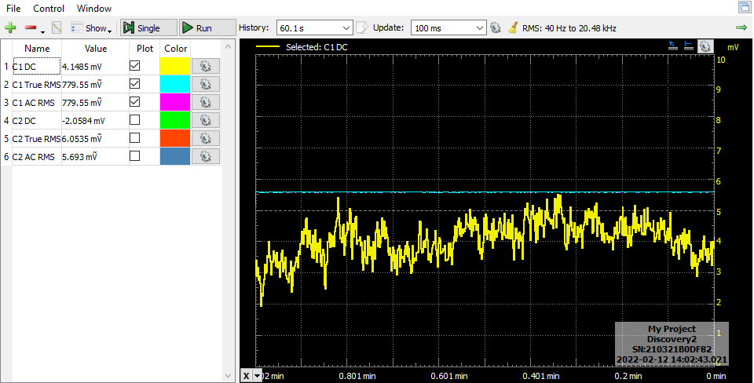**Figure 5.** Channel 1 Analog Discovery Logger Data

**Figure 6.** Channel 1 Analog Discovery Meter Data

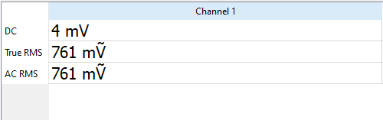

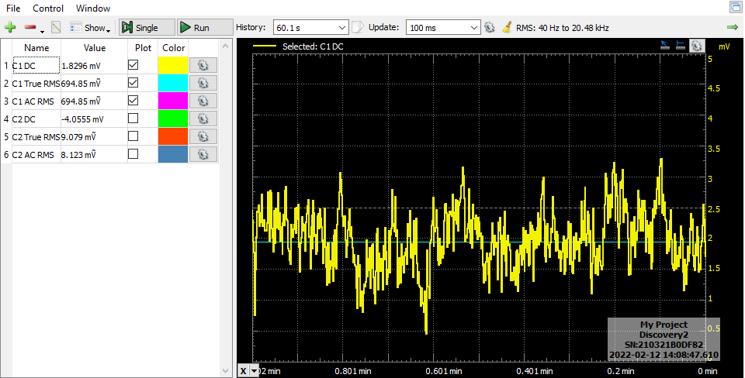**Figure 7.** Channel 2 Analog Discovery Logger Data

**Figure 8.** Channel 2 Analog Discovery Meter Data

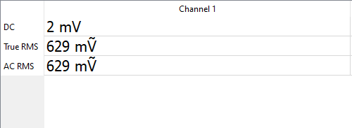

**Table 8.** Analog Devices Signal Generator Measurements Across Sensing Resistor

|  |  |
| --- | --- |
| Device | Resistor Voltage |
| Handheld Meter | 1.584V |
| Analog Discovery Meter (RMS) | 1.556V |
| Analog Discovery Data Logger (RMS) | 1.5941V |

In this table the input signal for the sensing circuit was generated by the analog discovery function generator. The input signal was 1KHz with an amplitude of 4.5 volts peak-peak.

**Figure 9.** Analog Discovery WaveGen out

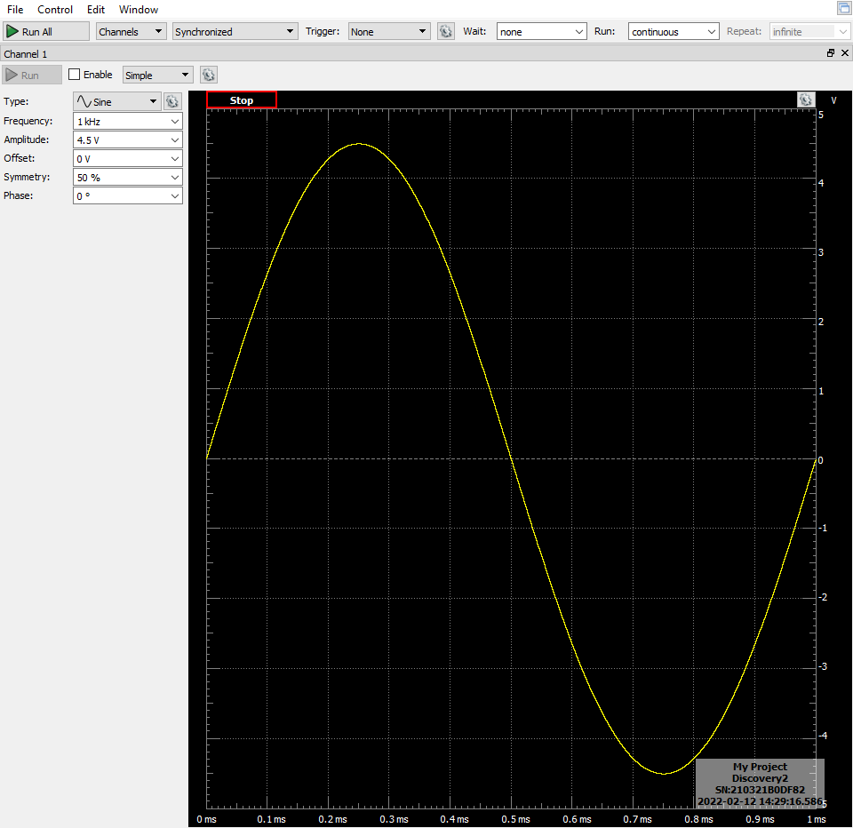

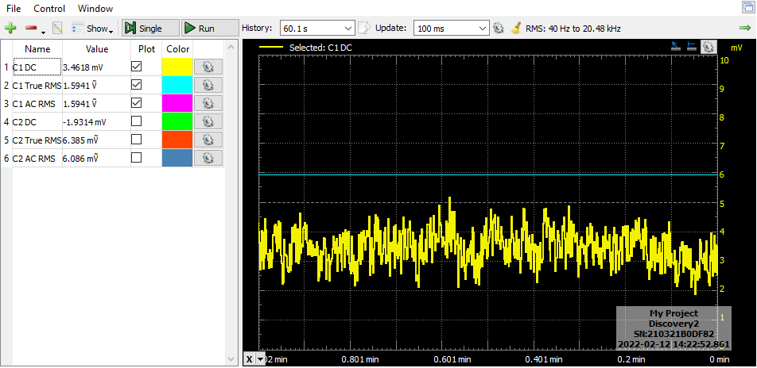**Figure 10.**  Analog Discovery Logger Data

**Figure 11.** Analog Discovery Meter Data

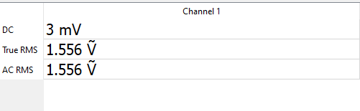

**Figure 12.** Analog Discovery Oscilloscope Measurement of Figure 9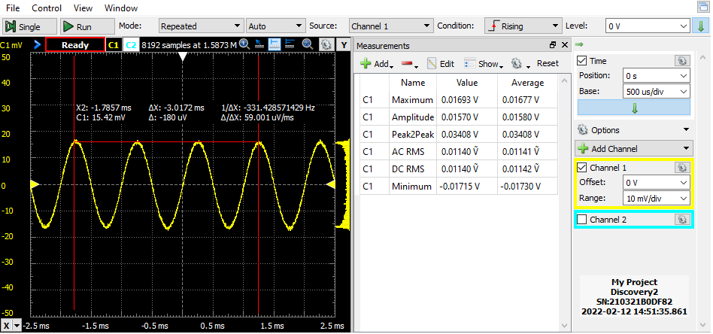

**Figure 13.** Matlab recreation of Channels 1’s waveform form sensing circuit

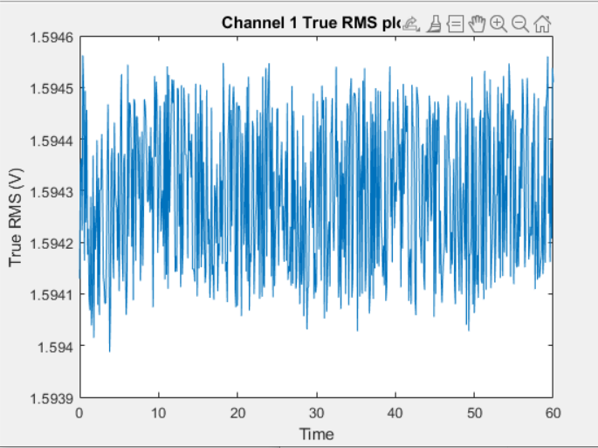

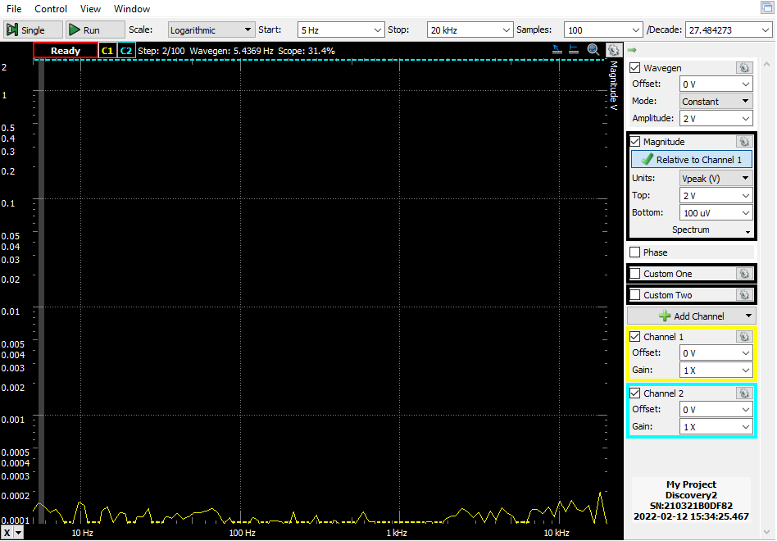**Figure 14.** Analog Discovery Network Analyzer Results

Results of measuring the network analyzer circuit

1. **DISCUSSION**

Multimeters are an important part of an engineer’s tool kit, and one must know what to expect when using it. In part 5 of the laboratory procedure, we measure a voltage, current, resistance, capacitance as well as check out some other functionalities of the handheld multimeter. When measure voltage or current, its necessary to expect values different than what was calculated. This is due to resistors and capacitors as well as power supplies having tolerances and not being able to meet ideal values. For example, when measuring the values of the capacitors, as the value of the capacitor went up, so did the percent error of the value. All in all, having an accurate meter an engineer can rely on is important.

When using a function generator, knowing how to set it to circuit equivalence (50Ω) or high-Z (high impedance) is a must. For the AFG1022 Function Generator, the procedure for setting this is on page 46 of its user manual. To do this, select the ‘utility’ button, then press ‘output setup’. After that, scroll through the options by pushing the button next to ‘CH1/CH2’. High-Z is important because set to 50Ω it would interfere with the signal(s) or the circuit being outputted to. For example, when the signal is driving something with near infinite resistance, such as MOSFET, it would cause it to have half of its gain. However, setting the output resistance to high-z, removes this issue.

Saving images from a measurement device like an oscilloscope is very useful when presenting data. The procedure to do this on the oscilloscopes available in lab, see the bottom of page 223 for a detailed procedure. To do this, press the ‘save/recall’ button. Then press ‘save’. After that, press ‘format’ and choose the desired format. The available format selections and their file types are Setup (.scp), 8-bit bitmap image (.bmp), 24-bit bitmap image (.bmp), 24-bit image (.png), csv data (.csv), ASCII xy data (.csv), reference waveform data (.h5), multi-channel waveform data (.h5), binary data (.bin), lister data (.csv) and mask (.msk). The file types used in this lab are Setup (.scp), so you can load your own setup via USB stick, and the 24-bit image (.png) for saving screen shots of the data. Another important part of the oscilloscope is the automated measurements. Instead of crunching numbers and risking error, the device will do this on its own. However, this function can also be used to double check personal calculations. The process for automatic measurements begins on page 176 of the user manual. To take these measurements, start by pressing the ‘Meas’ button. Then, select ‘source’ and choose which signal input what needs to be measured. After that, select the type of measurement wished to make by selecting ‘type’. The selected measurement will appear under the channels tab on the display in the measurements section. It is important to know how to utilize these features because they make easy to save or dissect a signal to show proof, record an issue, or to see the real values of an input or output.

Probe compensation is good to know. If probes are not working properly then the measurements will not be accurate. Fortunately, the provided and personal BNC probes where properly compensated. However, the procedure to manually compensate probes on located on page 29 of the oscilloscope’s user manual.

The procedure for setting the oscilloscope to X-Y mode is located on page 47 of its manual. To set the scope in the mode, begin by have two inputs into the scope. Next, auto scale the display be selecting ‘auto scale’. Then, press ‘Horiz’ and then ‘time mode’. After that, select ‘XY’ and adjust. Unfortunately, when I save this screen grab it was saved to the wrong file format, so I am unable to provide how it looks. I was also unable to find the procedure to set the oscilloscope in YT and XY display modes at the same time.

When looking at the function generator channel 1 output on the oscilloscope and the analog discovery’s oscilloscope function, they both looked quite similar. However, the benchtop oscilloscope had a cleaner image, but this makes sense, the analog discover is a device that can perform many functions well, where as the oscilloscope performs one function extremely well.

When looking at the function generators output on the oscilloscope and switching the output resistance from high-z to 50Ω and then back to high-z nothing about the appearance of the physical wave changed. However, the amplitude was cut in half. This is an expected result.

1. **CONCLUSION**

The objective of this laboratory procedure was to become familiar with note taking in the laboratory notebook and using the equipment available at each station. The equipment includes the following, InfiniiVision oscilloscope, Keithley benchtop digital multimeter, Tenma handheld digital multimeter the Digilent Analog Discovery and WaveForms, it’s software. After completing this procedure, I feel more comfortable at my station and with the devices and tools available there.

1. **QUESTIONS**

**N/A**

1. **REFERENCES**

Figures ‘a’: <https://lowell.umassonline.net/bbcswebdav/pid-1242548-dt-content-rid-10466135_1/xid-10466135_1>

Figure ‘b’ is taken from page 25 of the laboratory procedure.